Class: One **First Terminal Examination-2082**

Subject : Mathematics FM:50

Name: Roll No:

**Q.No.1) Tick (**√) **the best answer.**​​​​​​ **[10]**

a) There are _____ days in a week.

i) 10​​​​​ ii) 3 ​​​​​iii) 7

b) Which month comes just before April?

i) January ​​ii) March iii) May

c)The last day of a week is

i) Monday ​​ii) Saturday​​​ iii) Sunday

d) A triangle has ______ corners.

i) 3 ​​​​​ii) 2 ​​​​​ iii) 4

e) Which month comes between April and June?

i) January ​​​​​ii) May ​​​​​iii) July

f) There are _____ months in a year.

i) 10​​​​​ ii)12 ii) 15

g) _____ comes between 14 and 16

i) 13 ​​​​​ii) 12 ​​​​​iii) 15

h ) A rectangle has______ sides.

i) 1​​​​​ ii) 3​​​​​ iii) 4

i) There are ______days in a year.

i) 100 ii) 365 iii) 265

j) _____________comes just after Sunday.

i) Tuesday ii) Wednesday iii) Monday

**Q.N. 2) Look at the picture and fill in the blanks.**​​​ **[2]**

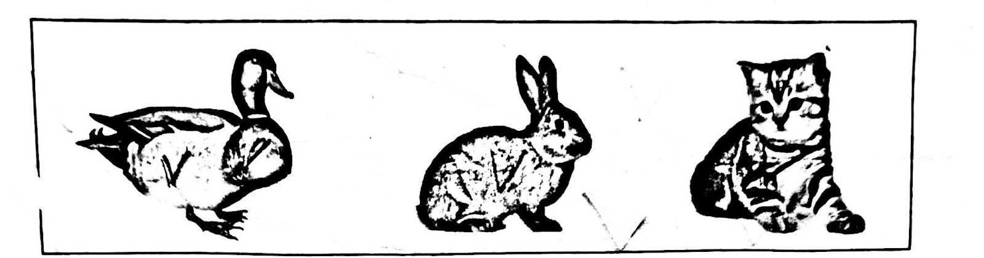

a) A______________ is sitting in front of Rabbit.

b) A___________is sitting between Duck and Cat.

**Q.N.3) What comes before ? [2]**

i)______ 5 ii)______9

**Q.N.4) What comes after? [2]**

i)9______ ii)6_______

**Q.N.5) What comes in between? [2]**

i)2____4 ii)7_____9

**Q.No.6) Match the following. [4]**

9 १०

10 ९

3 ७

7 ३

**Q.No.7)Write the number names in Hindu Arabic. (6)**

For example: 2 = Two

a)8= _______ b) 7 =________

c) 5 =________ d)9 =_________

e)6=________ f)4=________

**Q.No.8)Write the number names in Devanagari. (6)**

For example: ३ = तीन

a)१ = _______ b) ४ =________

c) ५ =________ d)१० =_________

e) ८=________ f)२ =_________

**Q.No.9] Draw the hour hand of the clock to show the given time. (4)**

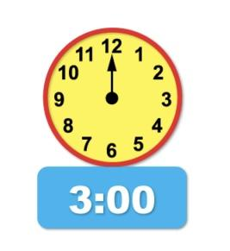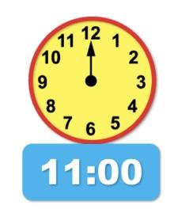a) b)

**Q.No.10] Write the time that these clock show. (4)**

a) b)

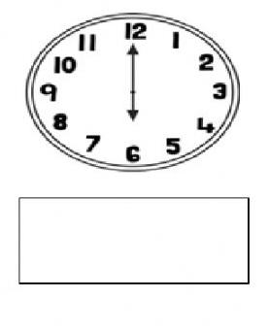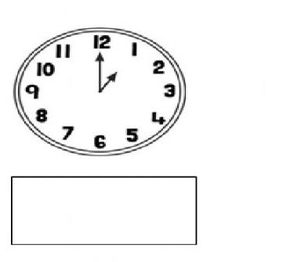

**Q.N. 11) Write the multiplication table of 2.**​​​​**[4]**

|  |
| --- |
| 3 X 1 = 3  3 X 2 = _____  3 X 3 = _____  3 X 4 = ___12__  3 X 5 = _____  3 X 6 = _____  3 X 7 = __21___  3 X 8 = ______  3 X 9 = ______  3 X 10 = ______  3 X 11 = ______  3 X 12 = 36 |

**Q.N.12) Draw a triangle and square. (4)**

|  |
| --- |
|  |

**The End**